|  |  |
| --- | --- |
| **Register No:** | **99220040570** |
| **Name** | **K.Hanumaan** |
| **Class/Section** | **8501A/S06** |
| **Ex. No:** | **1** |
| **Name of the Experiment** | **Study of Network Tool – Packet Tracer** |
| **Google Drive link of the packet tracer file (give view permission):** | <https://drive.google.com/drive/folders/1FuCTvBTUh5XnyRgpvwUWLaT9ISQ4OYKs?usp=>  drive_link |

1. **Device Requirements:**
   1. Switch
   2. PC0
   3. PC1
   4. Wires
2. **Network Diagram for your experiment (draw the diagram either hand drawing/ms paint or any other drawing tools)**
3. **Network Diagram (packet tracer diagram before configuration):**

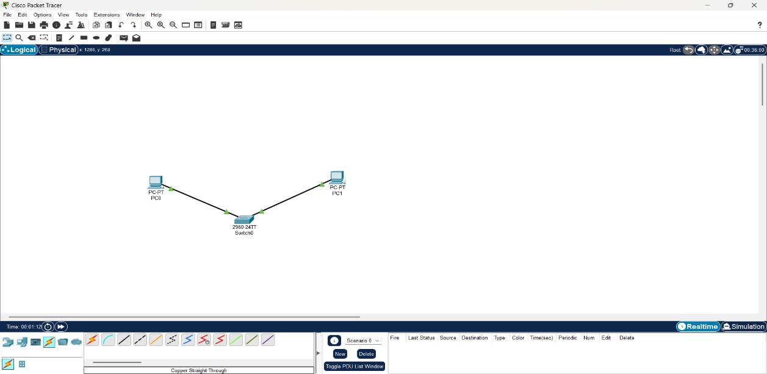

1. **Configuration details:**

|  |  |  |  |
| --- | --- | --- | --- |
| **Device Name** | **Interface Name** | **IP Address** | **Subnet mask** |
| PC0 | Fa0 | 172.16.108.25 | 255.255.0.0 |
| PC1 | Fa0 | 172.16.108.26 | 255.255.0.0 |
| Switch | Fa0 |  |  |

1. **Commands used in each of the diagram (if any):**
   1. Ipconfig
   2. Ping
2. **Output Diagram (Minimum 3 screenshot):**

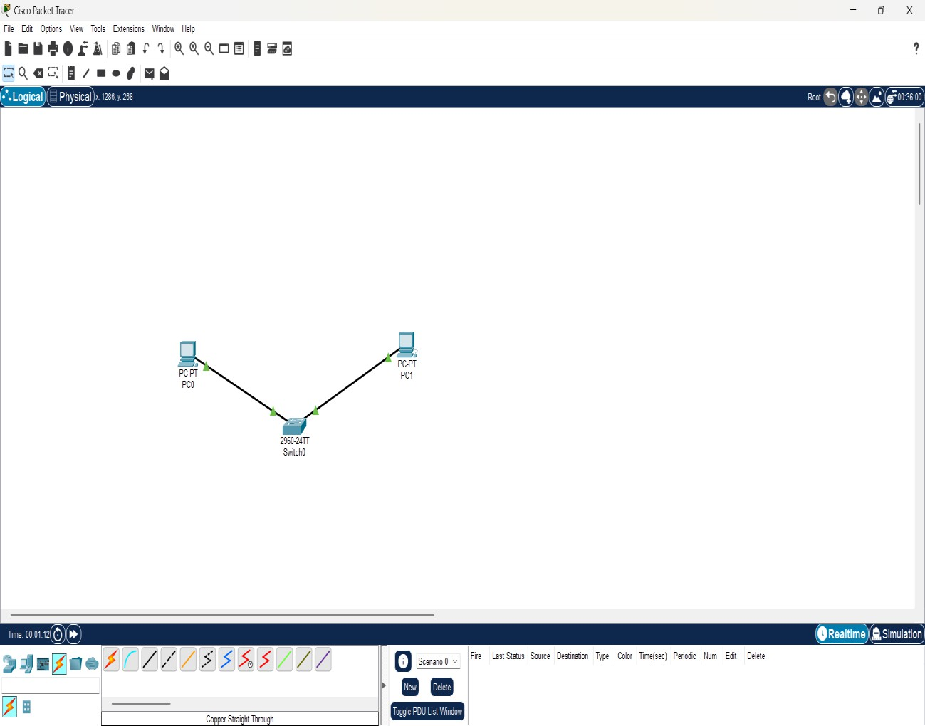

**Network Diagram**

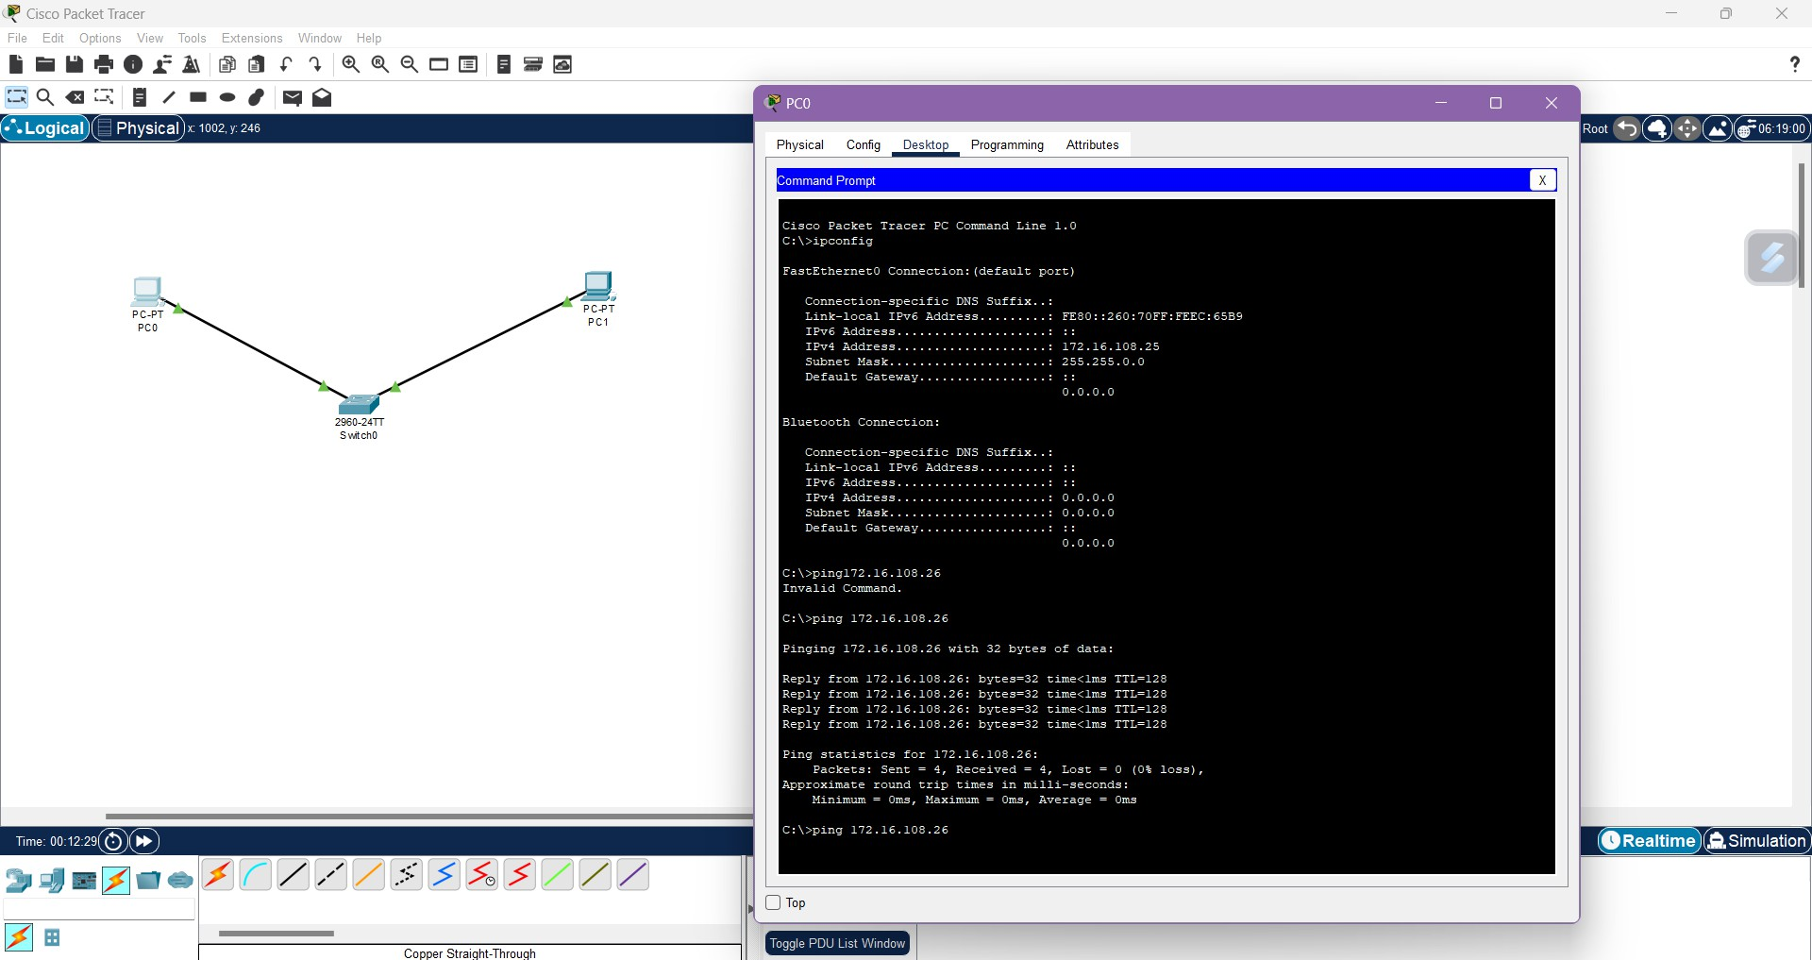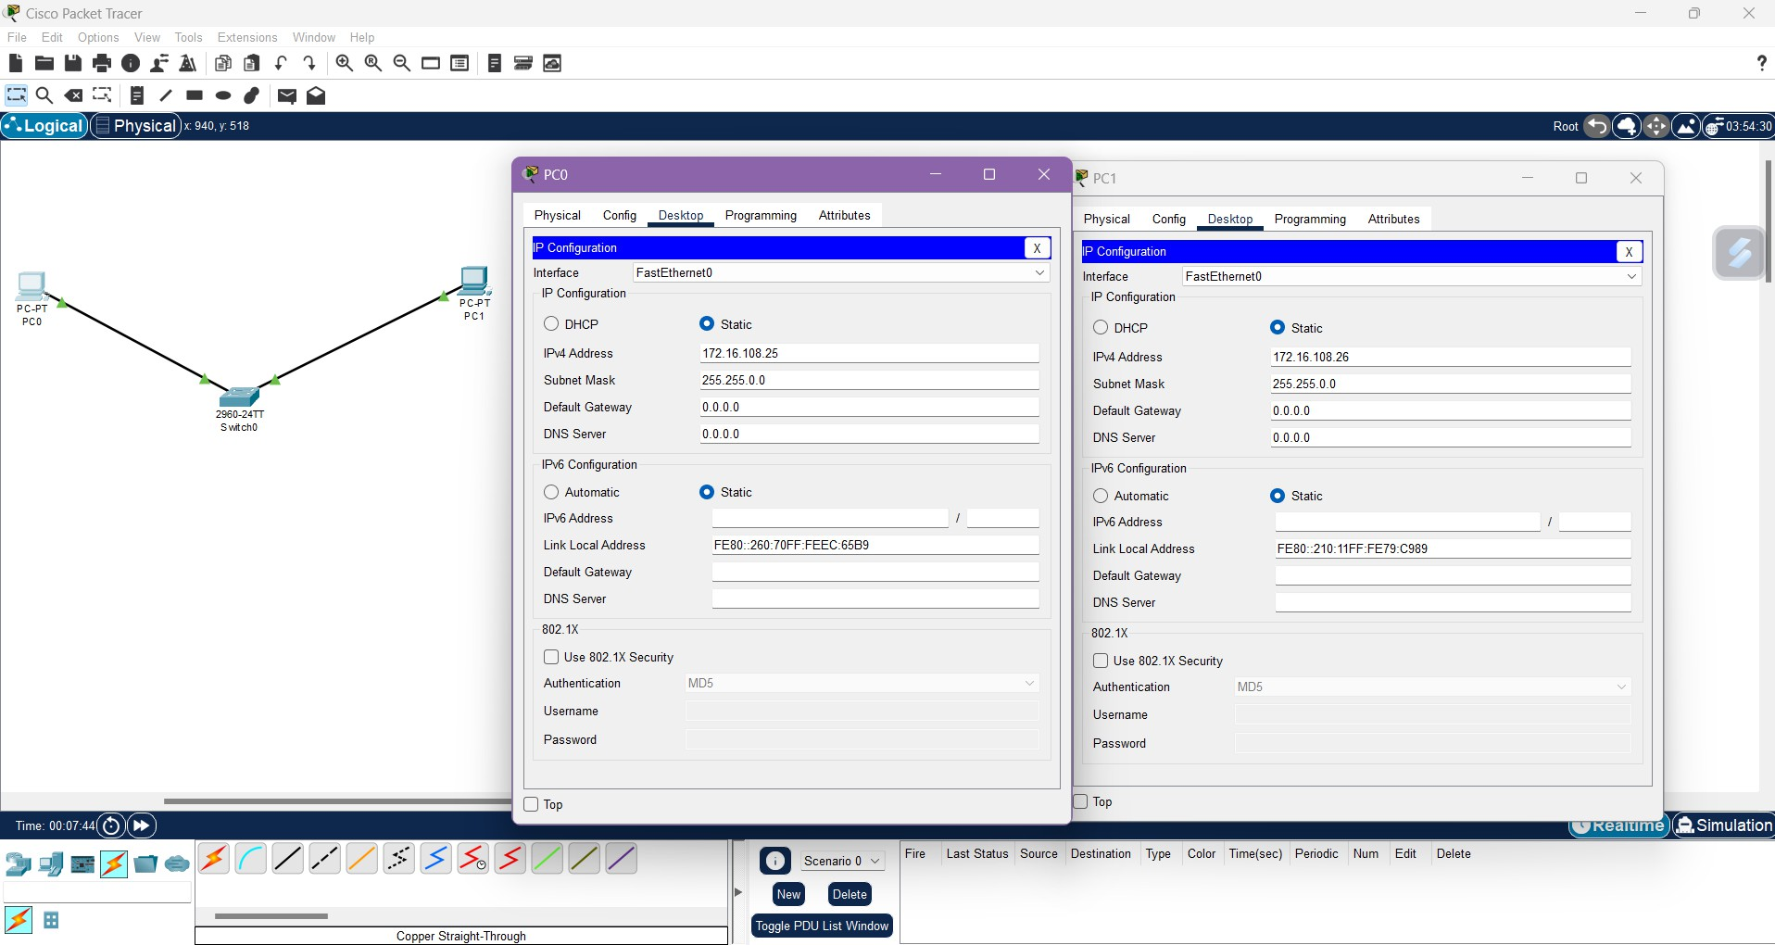

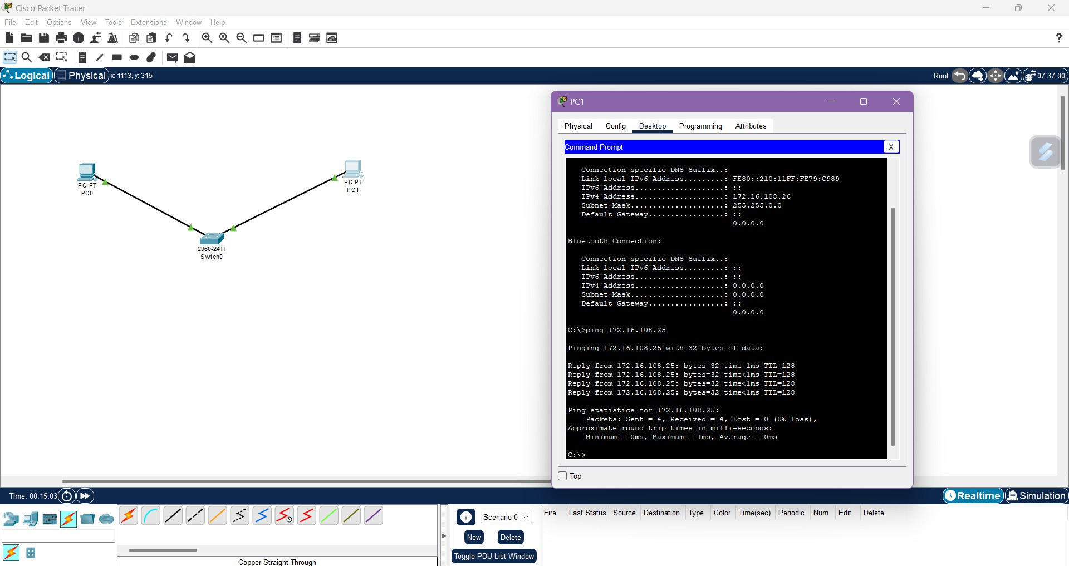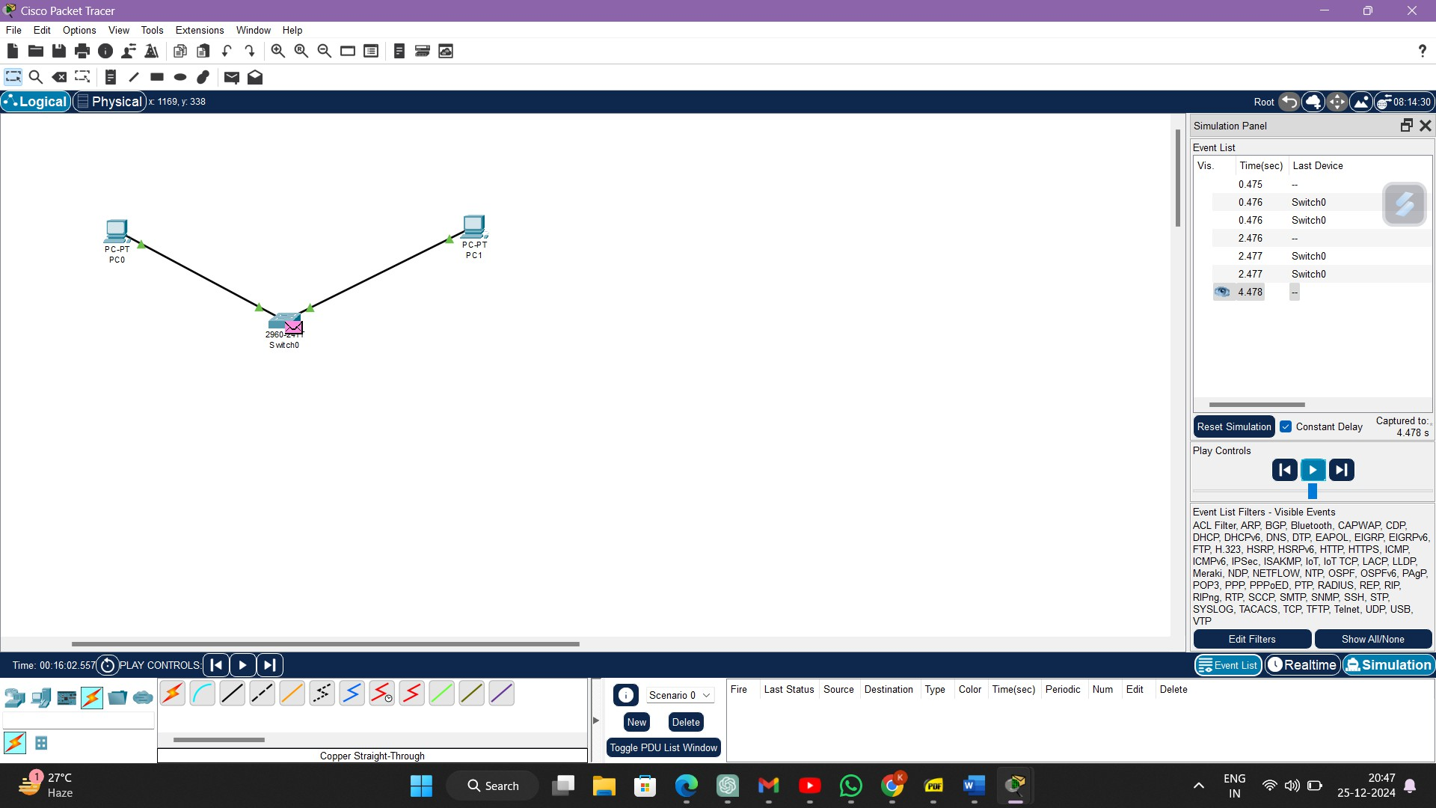**Assigning IP Address**

**Google Drive link of the packet tracer file (give view permission):**

**Link:** <https://drive.google.com/drive/folders/1FuCTvBTUh5XnyRgpvwUWLaT9ISQ4OYKs?usp=drive_link>

**CONCLUSION:**

The study concludes that Packet Tracer is a robust and user-friendly tool for network simulation and education. It plays a critical role in preparing individuals for industry certifications and real-world network management challenges. Its capabilities, combined with its accessibility, make it a cornerstone in the toolkit of network engineers and educators.

**Rubrics for Experiment Assessment:**

|  |  |  |  |  |
| --- | --- | --- | --- | --- |
| **Rubrics** | **Good** | **Normal** | **Poor** | **Marks** |
| **Creation of Topology (4)** | Created the topology, Identify the proper devices and making the connections **(4)** | Created the topology, Identify the proper devices, making the connections But missing some features **(3)** | Created wrong topology, Failed to Identify the proper devices and making connections **(1)** |  |
| **Verify the connectivity (4)** | Verified the connectivity in all the levels **(4)** | Verified the connectivity at some levels (only some nodes) **(2)** | Verified the connectivity is not done. **(1)** |  |
| **Timely Completion (2)** | Completed the lab before the allotted time **(2)** | Completed the lab after the deadline **(1)** | Did not submitted before grading **(0)** |  |
| **Tota**l | | | |  |

**Result**: Thus the Study of Network Tool - Packet Tracer has been done successfully.